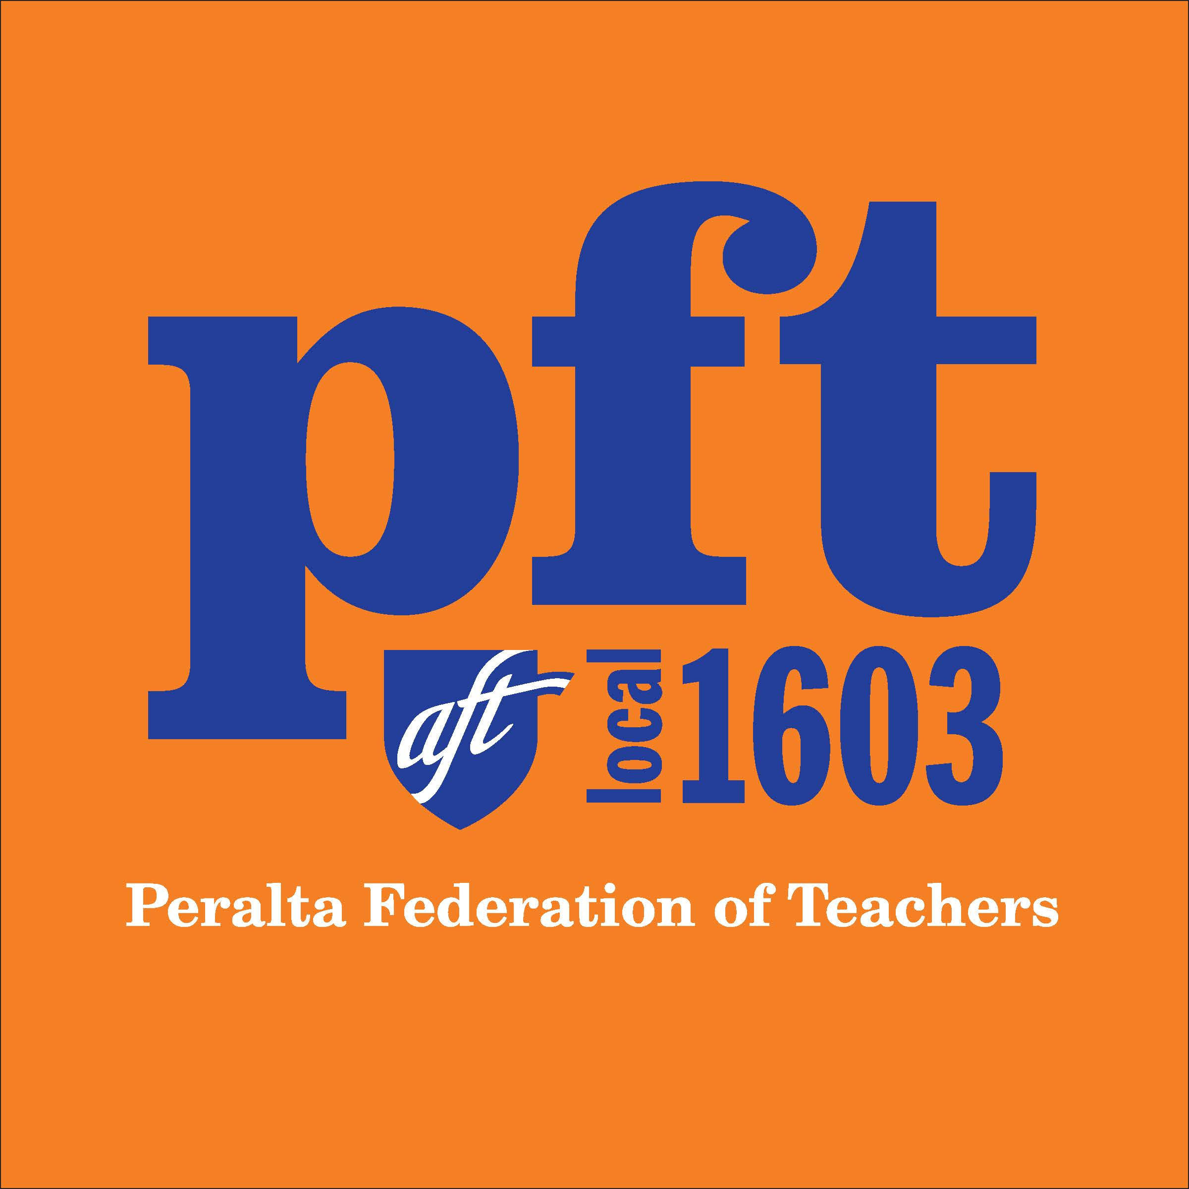

September 1, 2016

The Honorable Edmund G. Brown, Jr.
Governor, State of California
State Capitol, First Floor
Sacramento, CA 95814

Re: Assembly Bill 1690 (Medina) Position: SUPPORT
(as amended on 3/14/16) & Assembly Bill 2069 (Medina)

Dear Governor Brown:

My name is _______________. I am currently a part-time faculty member at Peralta Community College District.
I am writing to express my strong support for AB 2069 and AB 1690 (Medina) and respectfully request your signature on these important pieces of legislation. This legislation (both bills) , once signed into law, will provide me and tens of thousands of my part-time faculty colleagues across the state of California with the minimum standards for job security that we need to support our families and ensure a high-quality education for California’s community college students.

In California, part-time faculty teach nearly 50% of all community college course sections. These part-time faculty are required to hold the same academic qualifications and credentials as their full-time colleagues. However, in most cases, part-time faculty are paid significantly less than full-time faculty for the same duties of preparation, teaching, grading and assessment. In addition to receiving significantly less in compensation than their full-time counterparts, in most cases, part-time faculty receive no health coverage and are not compensated for office hour time outside of class to meet with students.

This lack of dignity, fairness and equity translates into poor prospects for career advancement and results in many qualified part-time faculty leaving the profession annually. AB 1690 seeks to enhance the retention of qualified instructors, support institutional viability and directly contribute to student success – a goal of all stakeholders in California’s Higher Education community.

Specifically, AB 1690 will require those community college districts that have not entered into a collective bargaining agreement as of January 1, 2017 to engage in negotiations with their part-time faculty for the purpose of retaining qualified part-time faculty and establishing a seniority list that will govern the offering of new assignments or a reduction in assignments. Those districts that already have such an agreement in place are exempted from the requirements of this bill.

Because AB 1690 relies on the local bargaining process and the existing local evaluation process to create and maintain a system of seniority, the flexibility and autonomy of the local community college districts are maintained while minimum standards for fairness for part-time faculty are ensured. For these reasons, I respectfully request your signature on AB 1690 and AB 2069.
Sincerely,

Signature:
Print name:
Title:
College(s):

